# **Evaluation sheet**

Here's the scorecard you can use to evaluate your own presentation. Or, even better: ask someone else to give feedback. You can also do this with a person who is also taking this course. In the next lesson, I'll explain how you can find that person.

**What the stars mean:** ﻿﻿⭐️ Poor  
﻿﻿⭐️⭐️ Fair  
﻿﻿⭐️⭐️⭐️ Good  
﻿﻿⭐️⭐️⭐️⭐️ Very good  
﻿﻿⭐️⭐️⭐️⭐️⭐️ Excellent

**Want to print the evaluation sheet?** ﻿﻿Download the PDF via the link at the bottom of this lesson.  
 ﻿﻿  
﻿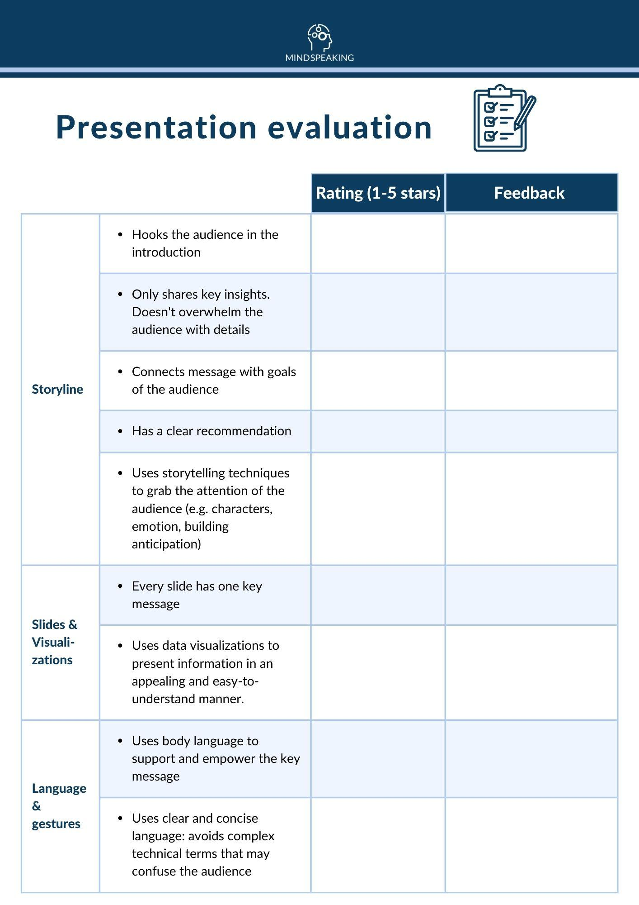  
﻿﻿

# **For the best results, record your baseline presentation**

**﻿﻿When you're creating this presentation baseline, it's best if you can record the presentation. Then you can review certain parts multiple times.**

Recording is easy for a remote presentation (just record on Teams or any other tool). But even in a face-to-face presentation, you can do so. If you don't like the idea of getting filmed by someone else, record a dry-run of your presentation and save it on your computer.

After the course, you do the presentation again. With a better storyline, and better presentation skills.  
**﻿﻿**